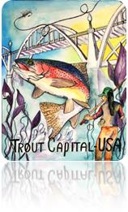
Cotter Trout Festival ~ Riverside Garden Party
Friday, May 1 - Big Spring Park, Cotter – Dinner at 6:30 p.m.

Art ~ Dinner ~ Music

Arrive early at 4:30 p.m. and observe the artists painting in
The “Quick Draw”
Art awards, show and sale at 6 p.m. with appetizers

Garden Party Dinner Menu by Chef Mikal Mershon – 6:30 p.m.
Gypsy Jazz Music –by Cutthroat Trout

For Details, visit http://www.cotterarkansas.com/calendar/events/

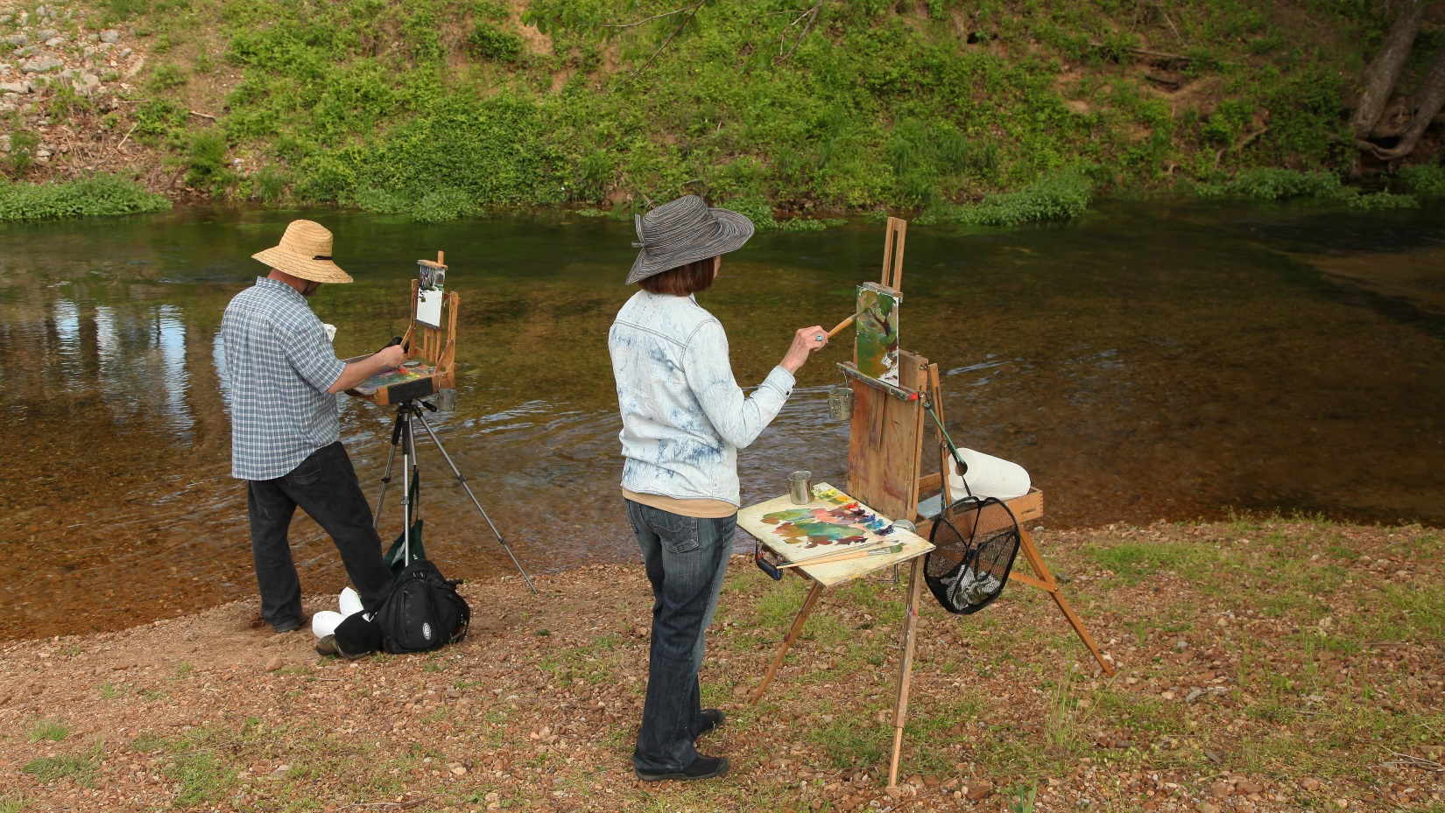
7th Annual Plein Air on the White River – “Quick Draw” at 4:30

