16th Annual - Cotter Trout Festival
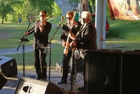

16th Annual - Cotter Trout Festival
Festival Events Include:
- Live Music throughout the day.
- Saturday, May 6th - Trout Festival Parade—Starts at 9:00am, lineup at 8:00am
- White River Lion’s Club—Charity Classic Car Show
- Kid’s Fishing Hole, AGFC Trout Aquarium, NAFF Demos and more Exhibitors/Vendors with great festival food
- And More
To Register as a Vendor, see VENDOR FORM below.
Booth Cost: $20.00 for 10’ X 10’, additional $10.00 for electricity.
For more information, email karentipton@centurytel.net, or call Karen Tipton at 870 404-3344.

VENDOR FORM

